Create and release a DACPAC

Lets see if I can release a new table.

1. First, fetch and pull the joe_dev branch of the repo so I know its up to date.
2. Run the script in Joe database to check it works.
3. Open Joe.sln. Make sure new table is added to the solution

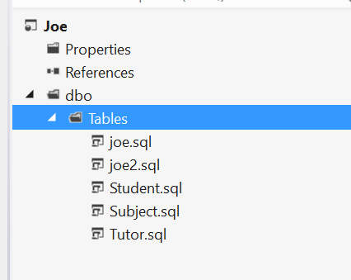

1. Commit and push changes to remote branch
2. Run the Joe_Test_Build pipeline on the joe_dev branch
3. Then create a release on the build and that’s it. Done!

**How did I create the Joe_Test_Build pipeline?**

These are the steps

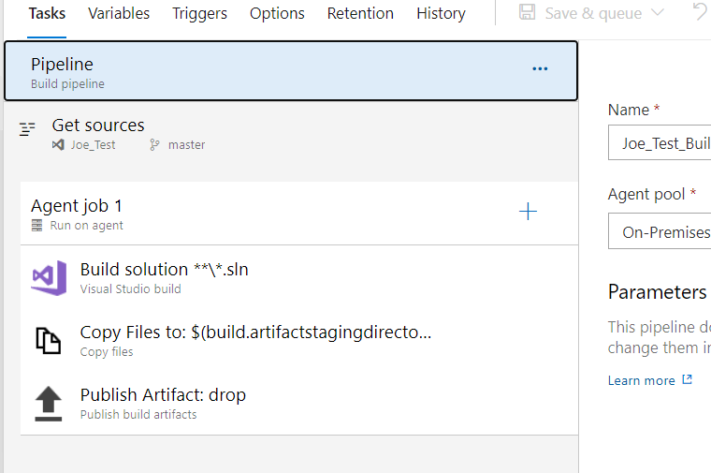

The first step shows what repository is being used

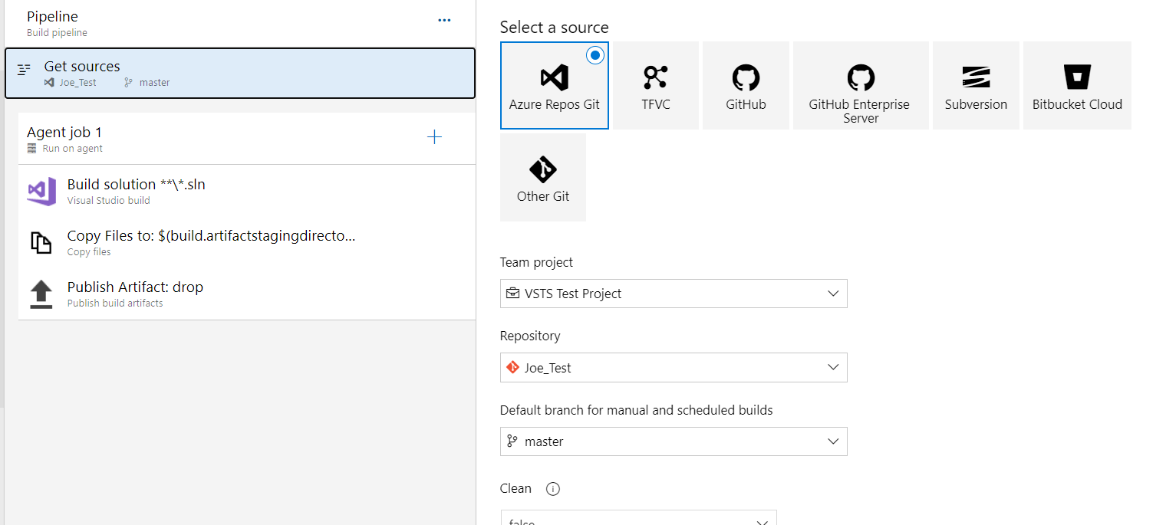

The second step builds the solution. Presumably this builds it on the repo branch that the build is running on.

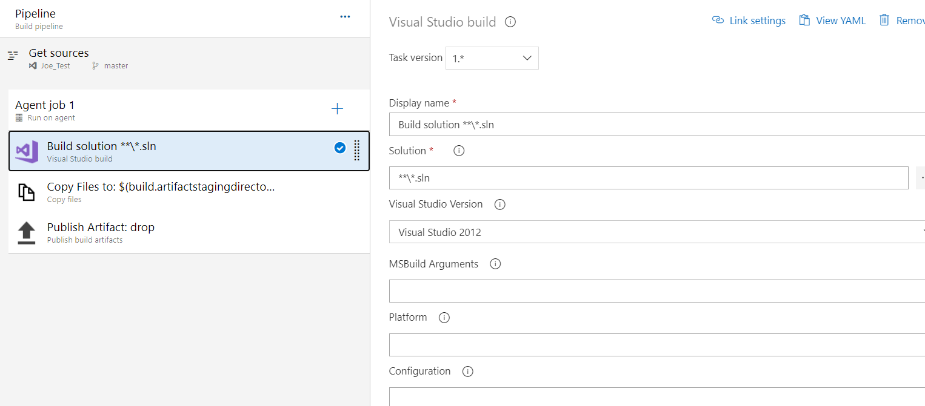

The next step copies the dacpac and config (ini) file to the build server. It uses these variables. But where are these defined?

$(build.sourcesdirectory)

$(build.artifactstagingdirectory)

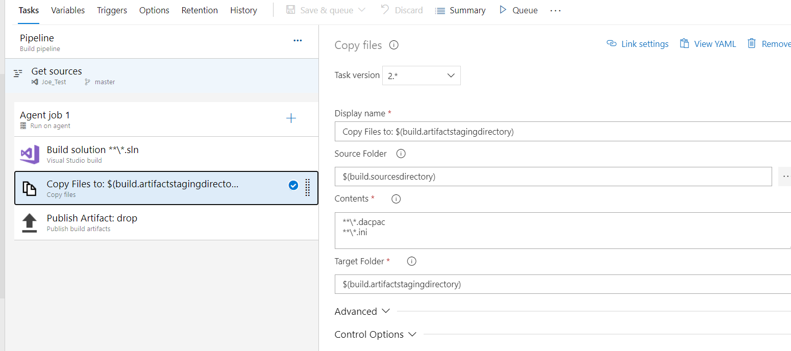

The last step publishes to an Azure pipeline. Not sure why this is but required by the release I guess.

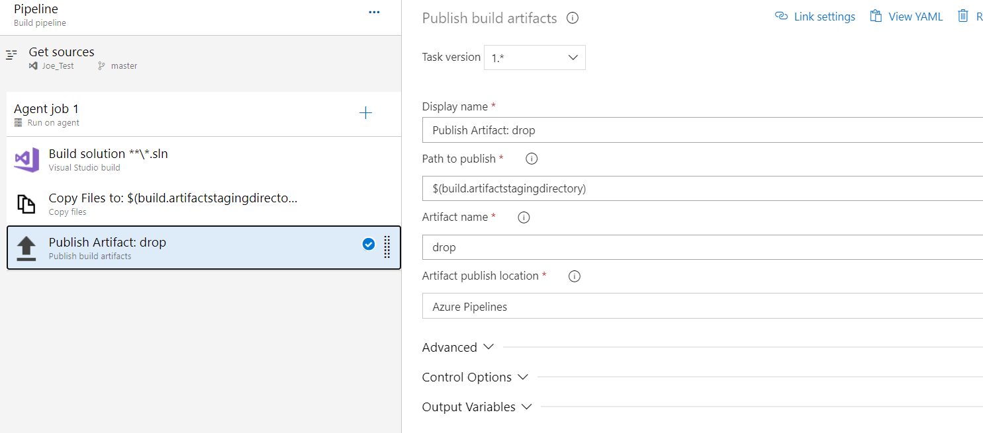

**But also you need to create a release pipeline**

Here it is, called Joe_Test and based on the Joe_Test_Build pipeline

It has one stage, called Development

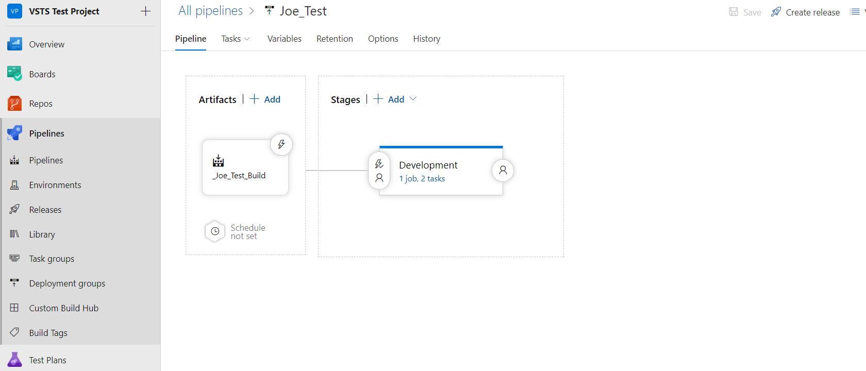

The Development stage has these tasks

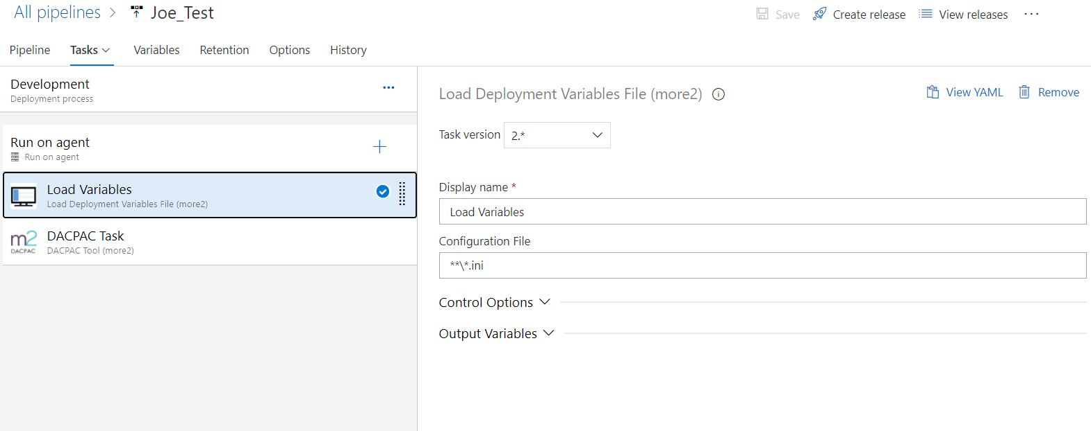

The Load Variable task does as it says, loads variables from the ini file.

The DACPAC Task actually releases the dacpac.

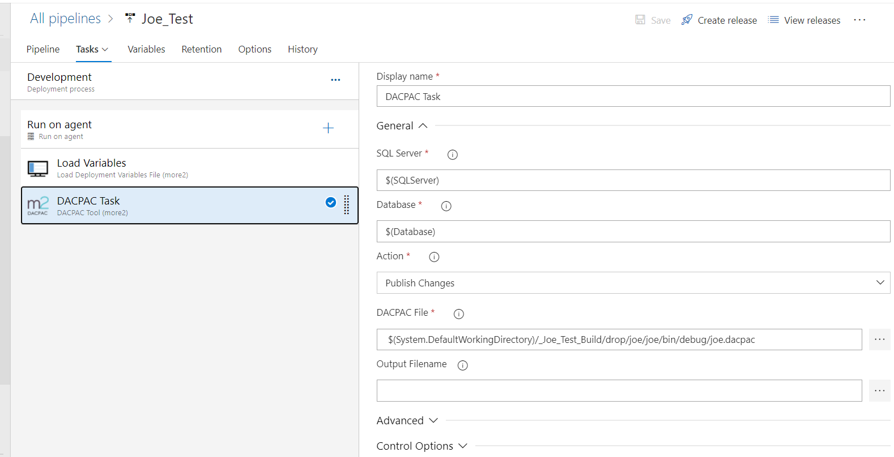

Note that there is a system variable defined somewhere. Which is where it is picking up the dacpac from. I wasn’t able to work out where this was defined.

$(System.DefaultWorkingDirectory)/_Joe_Test_Build/drop/joe/joe/bin/debug/joe.dacpac

So, the ini file has only these two variables in.

[Development]

SQLServer=M2LAP162

Database=JoeTest